**Profesisonal Portfolio**

by

Leandro Machado

Student Number

300326045

Douglas College  
Faculty of Business

CSIS 1280

Anupama Gupta

04 December 2020

## PROJECT SUMMARY

## DESCRIPTION

As a developer, an online portfolio works like a business card. The project titled Professional Portfolio is an attempt to produce, at least, a first version of one. To achieve such an objective, the developer uses three technologies: HTML, CSS and JavaScript.

The HTML and CSS are the noun and adjectives of a website, whereas JavaScript is known as the verb. Along with JavaScript, the jQuery framework will be used to help the development of effects and animations.

The project structure is as shown in Figure 1:

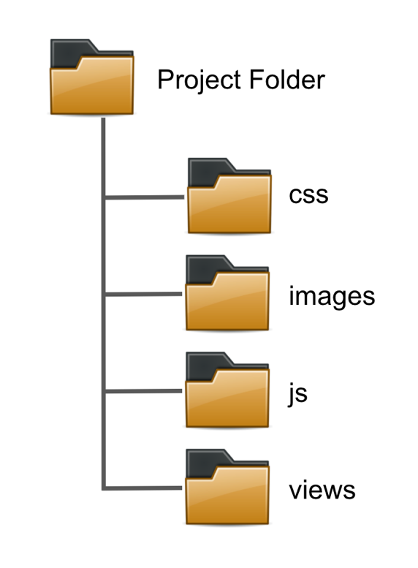

Figure 1-Project structure.

The root (project folder) will contain for folders: css, images, js and views. The css folder will have all files related to the styling of the page. The images folder will contain all photos and media related to the webpage content. The js folder will include the JavaScript files associated with the web page's behaviour, and the views folder will host all the .html files.

## WIREFRAME

The following set of wireframes represent the layout of the pages. The project takes into account media queries for portability in tablets and cell phones too.

The wireframe does not change for any view, what changes is the display of the columns inside those sections, for example, instead of showing three columns inside a se the mobile. In this document, it will be shown the notebook and mobile view, since the tablet view have only small changes If compared with the notebook view.

Index.html:

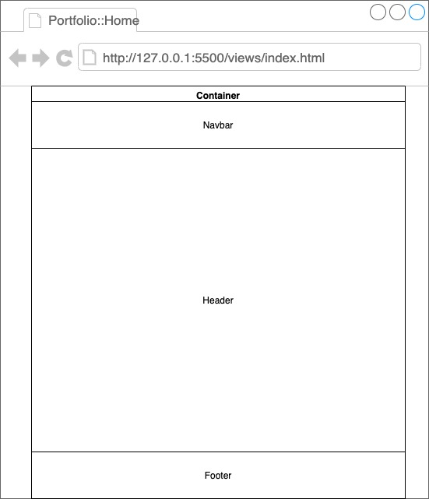

About.html:

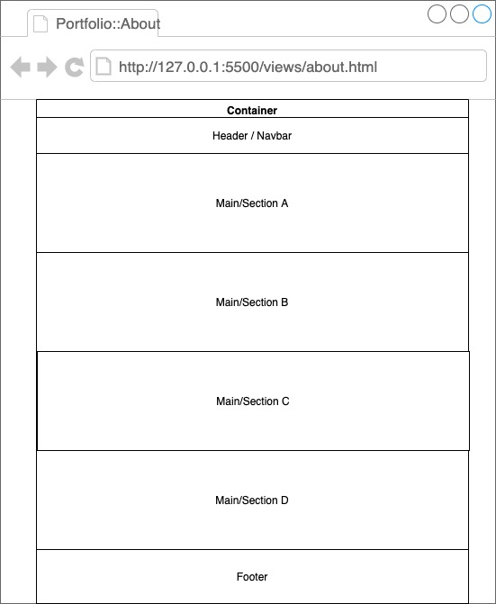

Work.html:

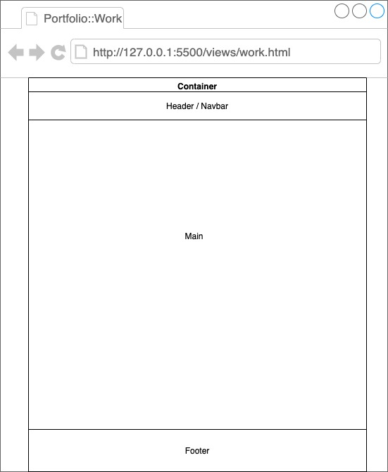

Contact.html:

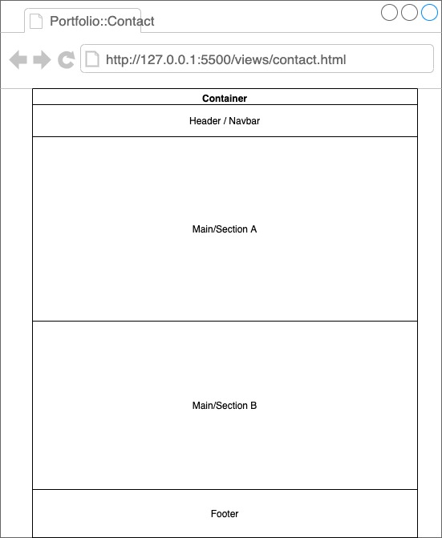

Notebook view: (max-width: 1200px for the container)

Index.htmlJust scroll the page to see the footer.

About.html

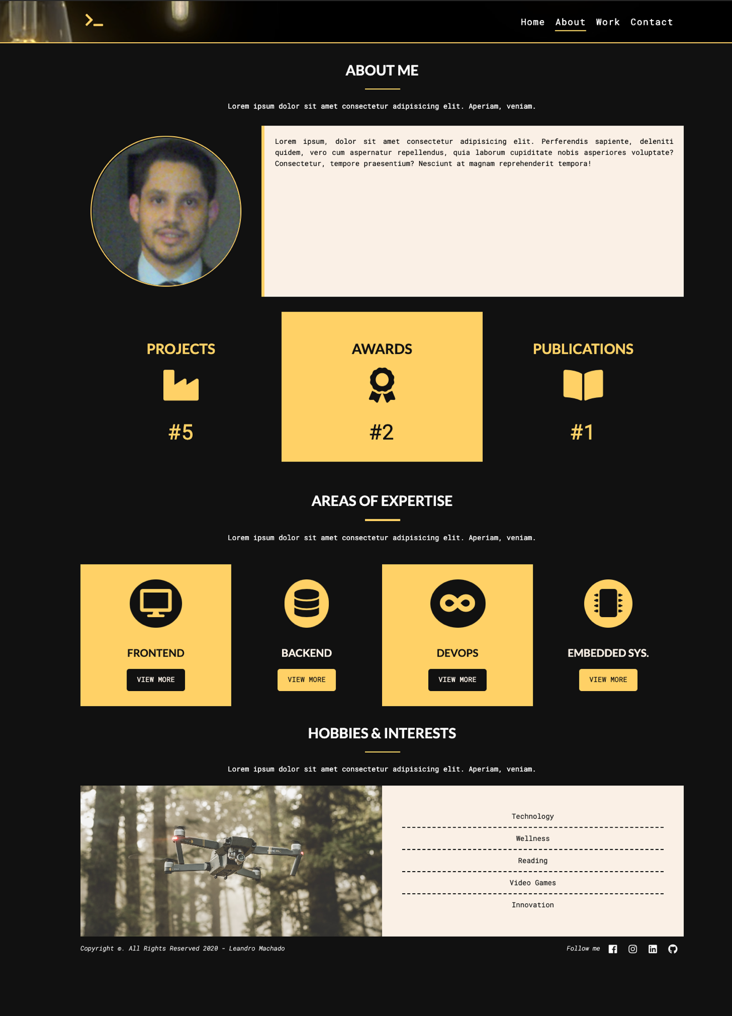

Work.html

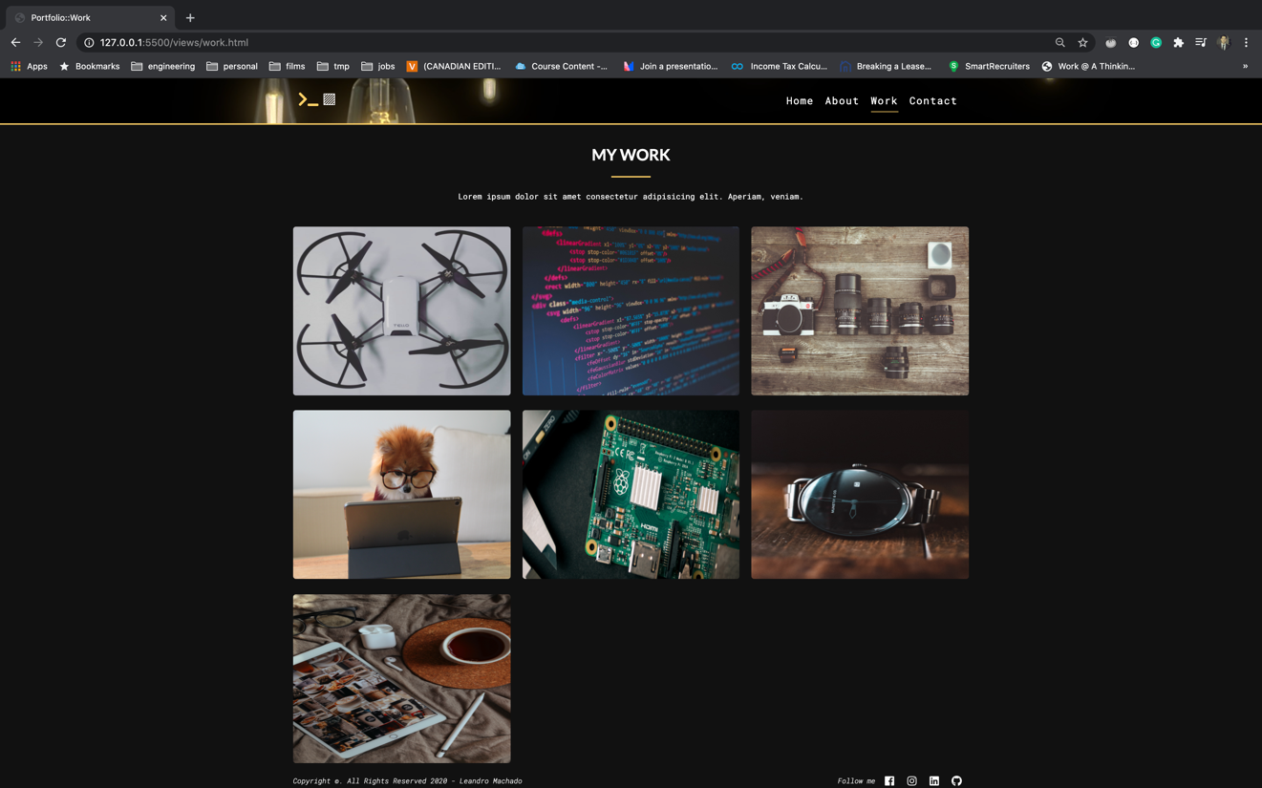

Contact.html

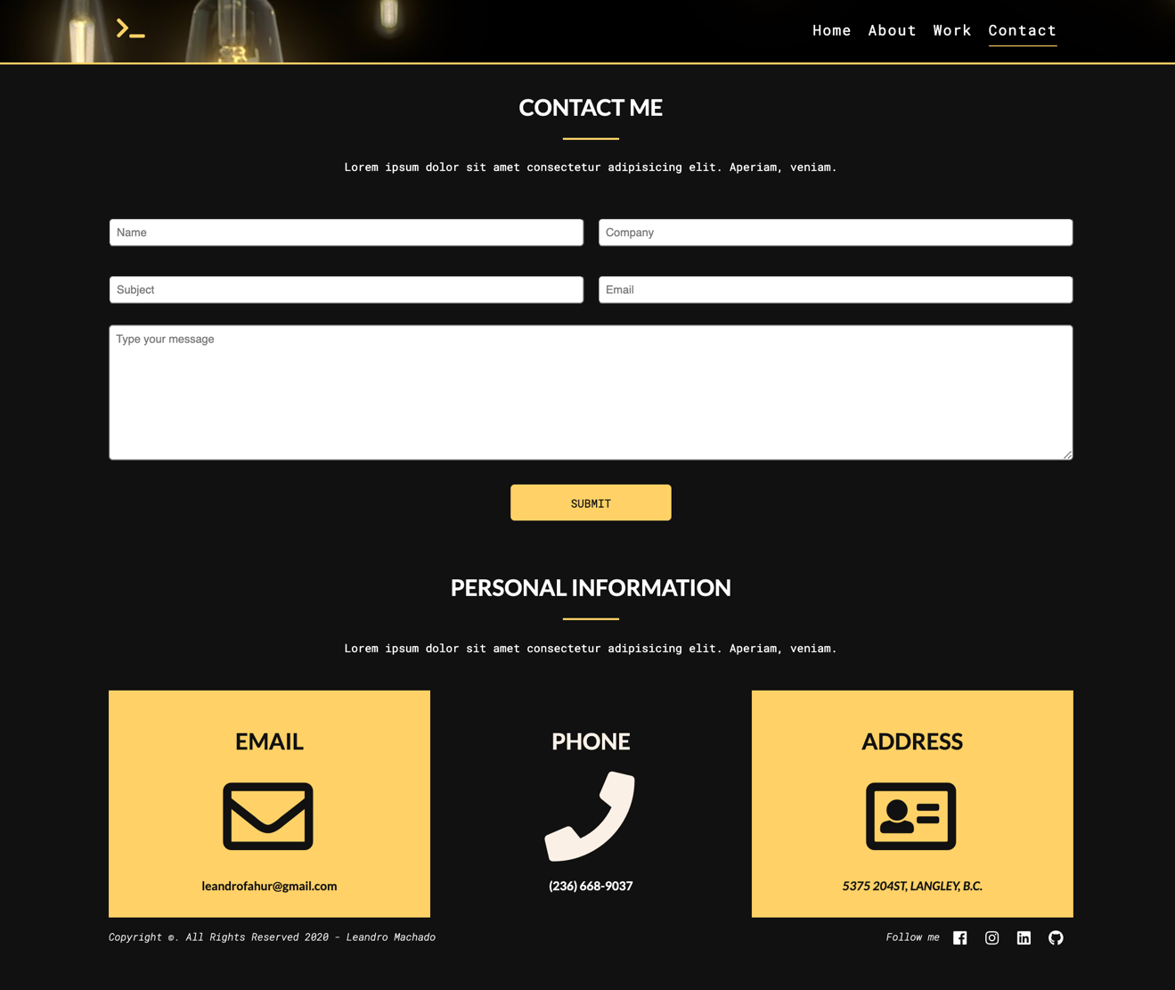

Mobile view: (max-width: 414px)

Index.html

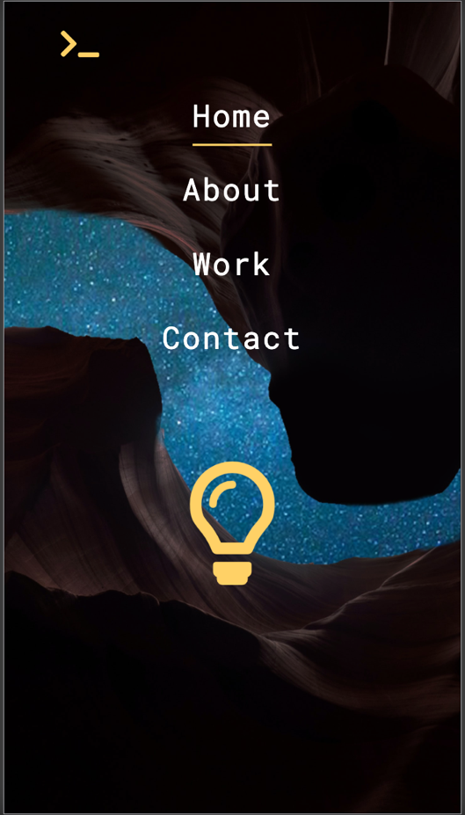

About.html

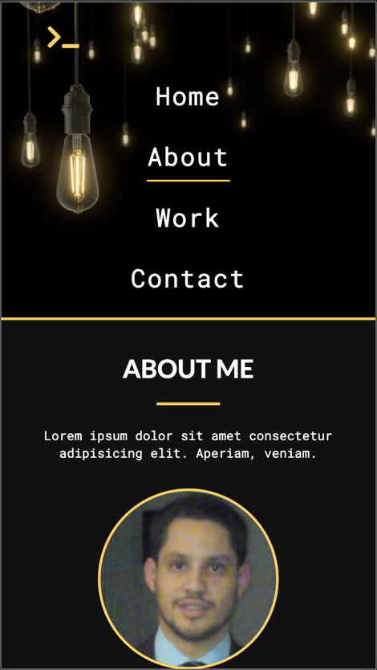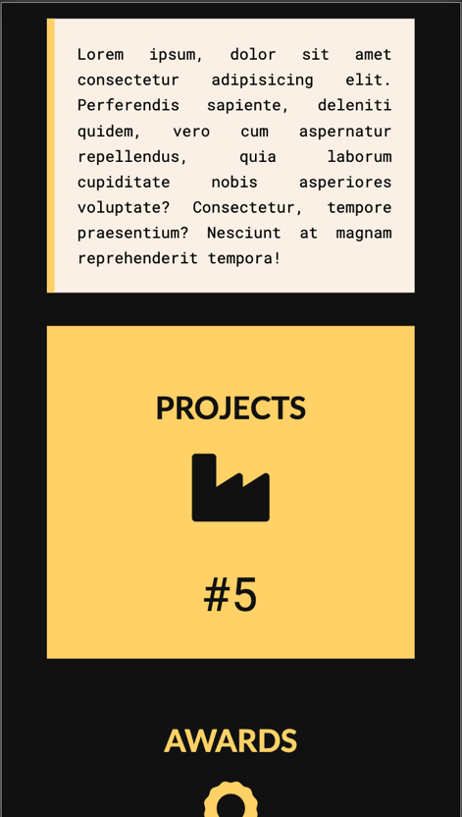

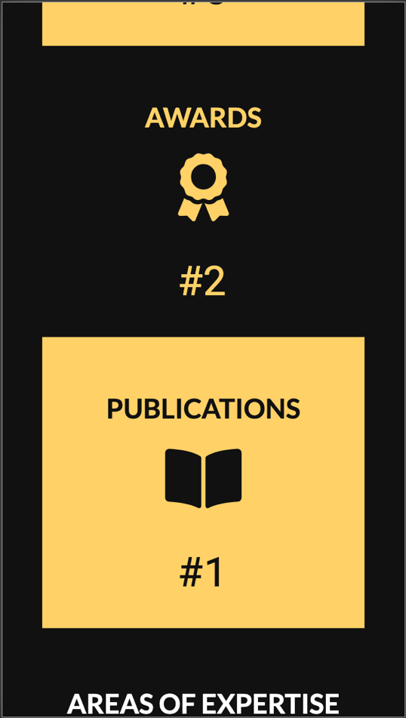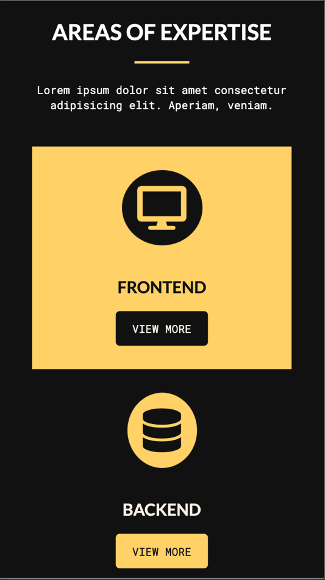

## 

Since the about page have more section, it will be the only one displayed with photos to exemplify how the content is displayed in a phone configuration.

## SITEMAP

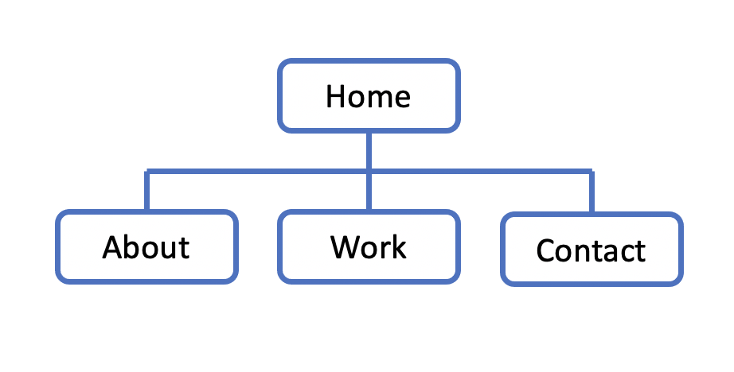

The present buttons on those pages are describe in the section “structure of each webpage” bellow.

## STRUCTURE OF EACH WEBPAGE

The site do not have a very complicated structure. In each and every page, the footer will contain four clickable icons: Facebook, Instagram, LinkedIn and GitHub.

The about page have a section called Areas of Expertise, each one present a ‘view more’ button. When clicked, each button open and a modal with information. The modal from the embedded sys. box open a video from YouTube, but does not access or route to the page itself.

The Contact page have a form section with a submit button, however, the button does not execute any post or get action from the HTTP, it only triggers events in JavaScript to evaluate the fields.

Reference List

|  |
| --- |
|  |
| Dean, J. (2018). web programming with html5, css, and javascript. Jones & Bartlett Learning. |

Felke-Morris, T. (2014). Web development and design foundations with HTML5. Addison-Wesley Professional.